**RIPHAH INTERNATIONAL UNIVERSITY**



**COAL LAB**

**Practie Questions**

**NAME:** AREEBA NADEEM

**SAP ID:** 57027

TASK 1:

.model small

.stack 100h

.data

msg db ' You Entered$'

msg1 db 'Character $'

main proc

mov ax, @data

mov ds, ax

mov dl, msg

mov dx, offset msg

mov ah, 9

int 21h

mov ah, 1

int 21h

mov ax ,bx

mov ah,2

int 21h

mov ax, @data

mov ds, ax

mov dl, msg1

mov dx, offset msg1

mov ah, 9

int 21h

mov ah, 4ch

int 21h

main endp

end main

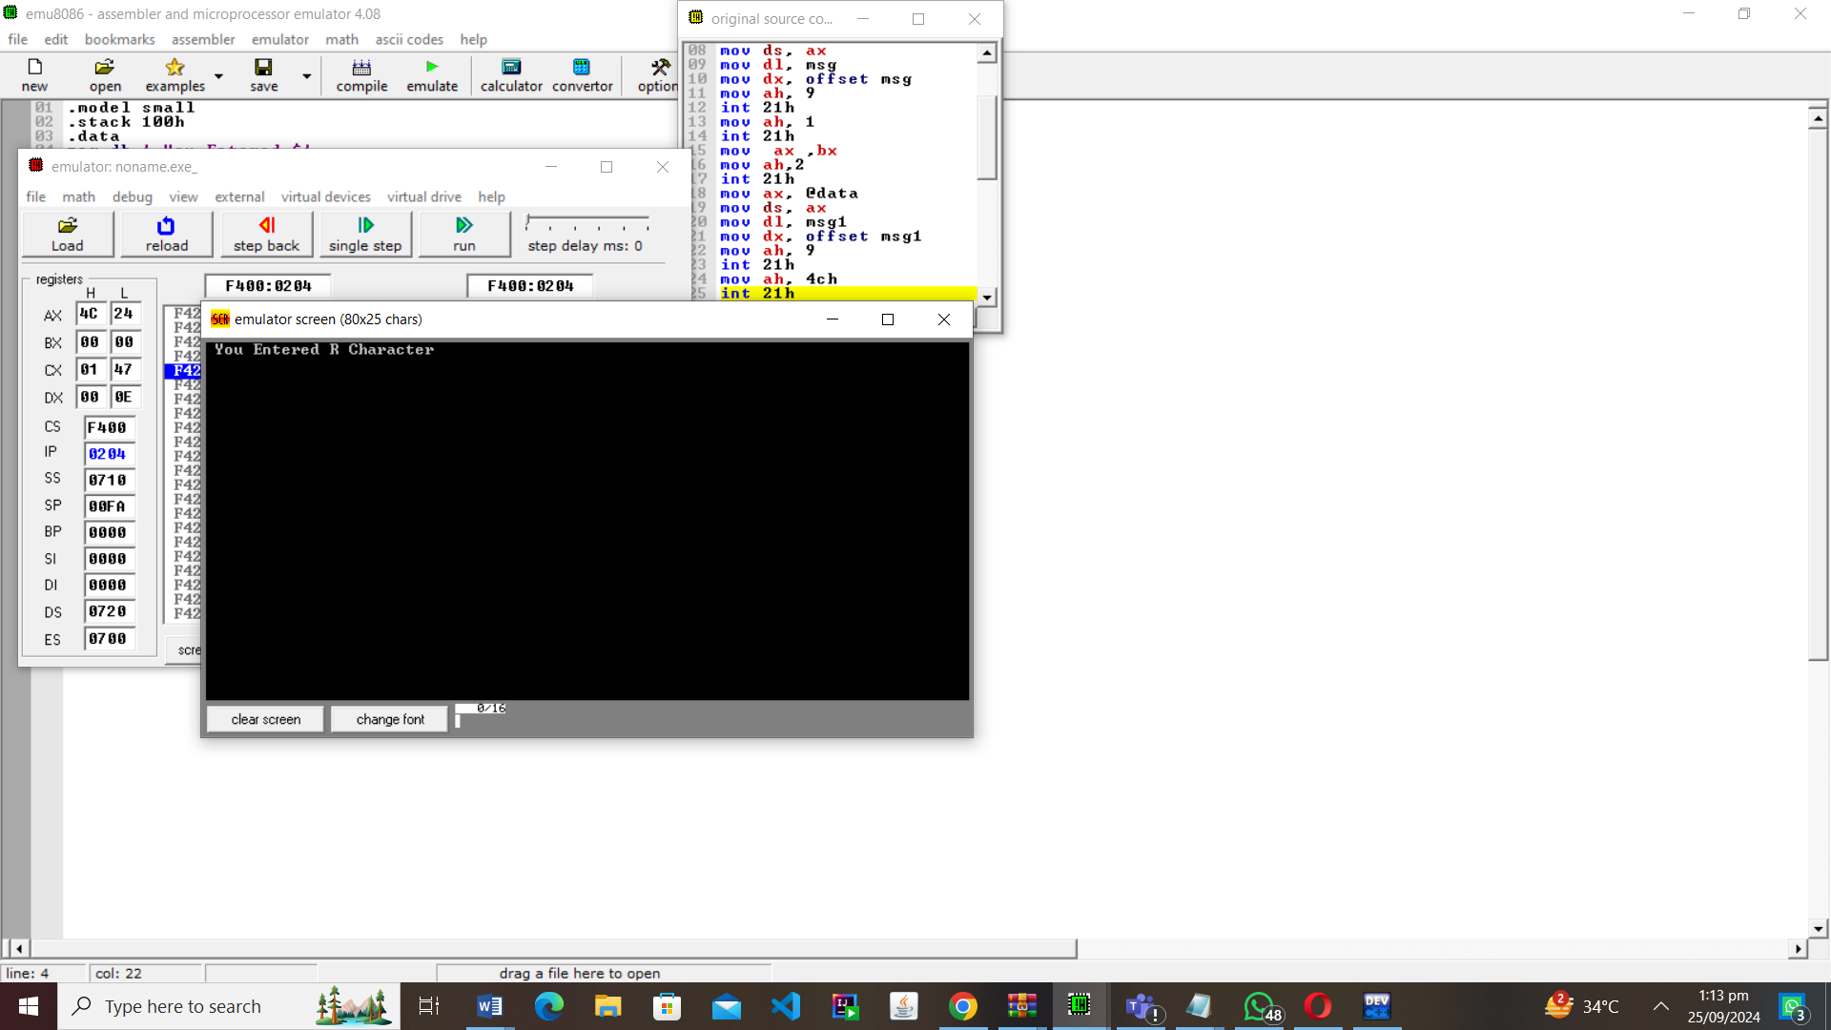

**TASK 2:**

.model small

.stack 100h

.data

msg DB 'My name is Areeba$'

mgf DB 'My Father name is Nadeem$'

mse DB 'My mother name is Ieam$'

msd DB 'Currently i am in Riphah International university$'

msa DB 'I am doing my bachelors in Software Engineering$'

msb DB 'I have done my Fsc in Pre Mdecical from kips college $'

msc DB 'I scored 1015 marks in Fsc$'

msw DB 'I have done my matriculation examination from al huda school$'

.code

main proc

mov ax,@data

mov ds,ax

mov dl,msg

mov dx,offset msg

mov ah,9

int 21h

mov dl,10

mov ah,02

int 21h

mov dl,13

mov ah,02

int 21h

mov dl,mgf

mov dx,offset mgf

mov ah,9

int 21h

mov dl,10

mov ah,02

int 21h

mov dl,13

mov ah,02

int 21h

mov dl,mse

mov dx,offset mse

mov ah,9

int 21h

mov dl,10

mov ah,02

int 21h

mov dl,13

mov ah,02

int 21h

mov dl,msd

mov dx,offset msd

mov ah,9

int 21h

mov dl,msa

mov dx,offset msa

mov ah,9

int 21h

mov dl,10

mov ah,02

int 21h

mov dl,13

mov ah,02

int 21h

mov dl,msb

mov dx,offset msb

mov ah,9

int 21h

mov dl,10

mov ah,02

int 21h

mov dl,13

mov ah,02

int 21h

mov dl,msc

mov dx,offset msc

mov ah,9

int 21h

mov dl,10

mov ah,02

int 21h

mov dl,13

mov ah,02

int 21h

mov dl,msw

mov dx,offset msw

mov ah,9

int 21h

mov ah,4ch

int 21h

main endp

end main

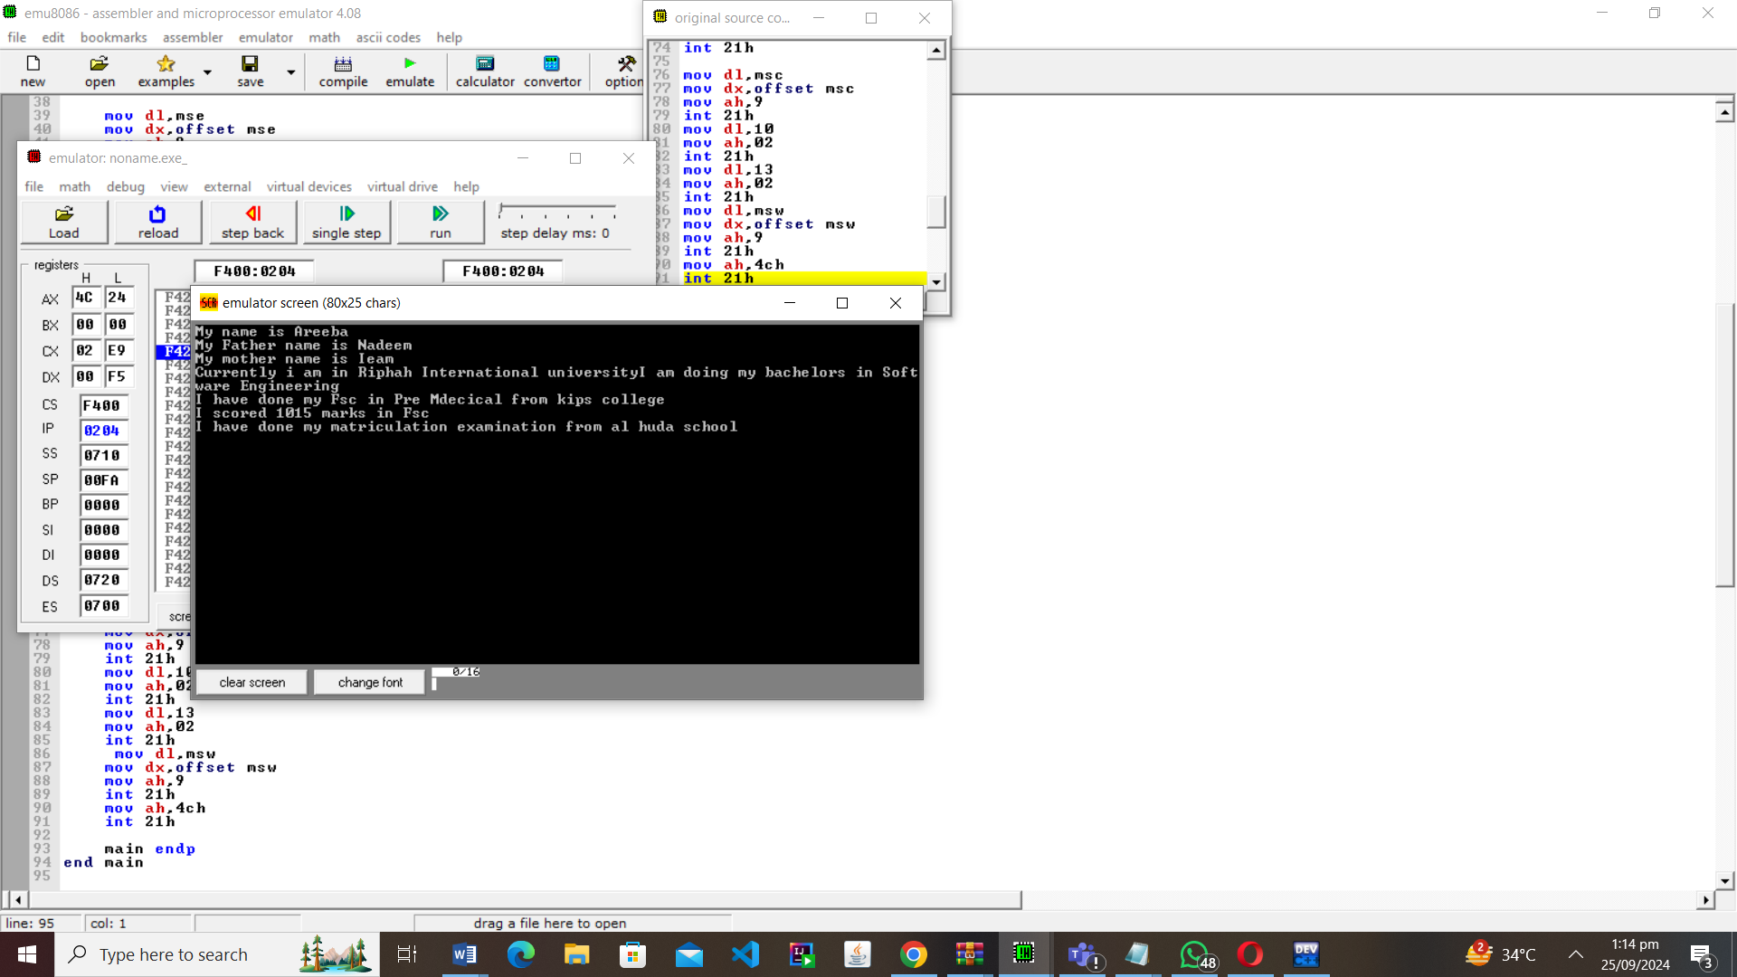

**TASK 3:**

.model small

.stack 100h

.data

msg1 db 'Enter a lowercase character: $'

msg2 db 'The uppercase character is: $'

.code

main proc

mov ax, @data

mov ds, ax

mov dl,msg1

mov dx, offset msg1

mov ah, 09h

int 21h

mov ah, 01h

int 21h

mov bx, ax

mov dl, 13

mov ah, 02h

int 21h

mov dl, 10

mov ah, 02h

int 21h

mov dl,msg2

mov dx, offset msg2

mov ah, 09h

int 21h

sub bx, 32

mov dx, bx

mov ah, 02h

int 21h

mov ah, 4Ch

int 21h

main endp

end main

